Digital Toolkit for Organizers and Partners
During Safe + Sound Week, your organization can encourage engagement around safety and health and recognize your members that are participating. Below are ideas to help you easily integrate Safe + Sound Week content into your communications channels every day during the event. You can also search for content posted by your members and circulate it.

Hashtag
Remember to use #SafeAndSound2018 when posting on social media platforms!

Daily Game Plan

Monday, August 13th – Start discussions about management leadership

#SafeAndSound2018 Week is here! Managers/Leaders: The example you set in the workplace is critical, and we want to hear from you.

AND/OR

Tell us your answer using #SafeAndSound2018
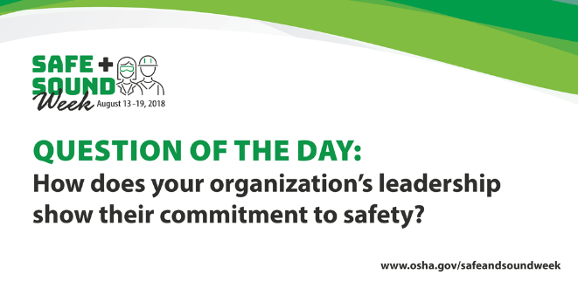

Tuesday, August 14th – Start discussions about worker participation

Worker participation is critical for an effective safety and health program. Tell us how you’re getting workers involved in #SafeAndSound2018.

AND/OR

Tell us your answer using #SafeAndSound2018
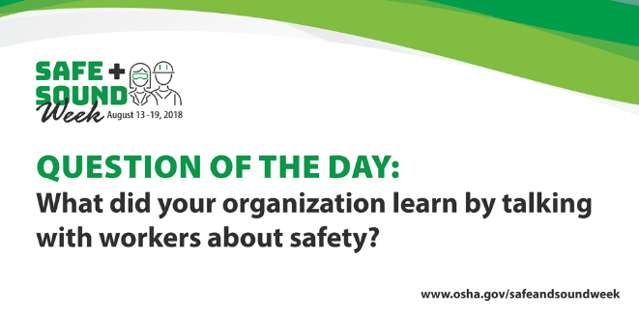

Wednesday, August 15th – Start discussions about finding and fixing hazards

You can improve workplace safety by making finding and fixing hazards part of your daily routine. Share something you have fixed during #SafeAndSound2018.

AND/OR

Tell us your answer using #SafeAndSound2018
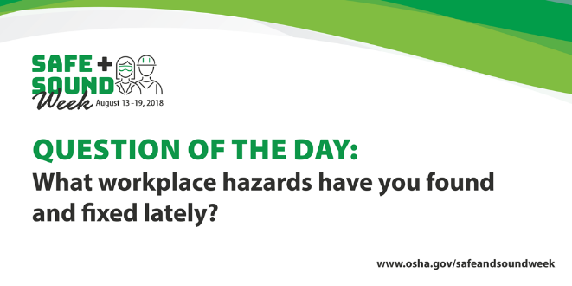

Thursday, August 16th – Start discussions about the value of safety and health programs

A safety and health program can prevent injuries and illnesses, strengthen your business, and increase worker satisfaction. What benefits did you see during #SafeAndSound2018?

AND/OR

Tell us your answer using #SafeAndSound2018
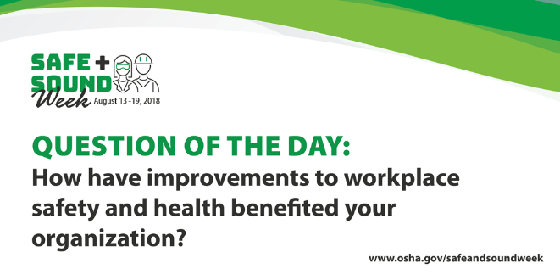

Friday, August 17th – Start discussions about making safety and health a priority throughout the year

Thanks for showing your commitment to safety this week! Tell us how you’ll continue your #SafeAndSound2018 activities throughout the year.

AND/OR

Tell us your answer using #SafeAndSound2018
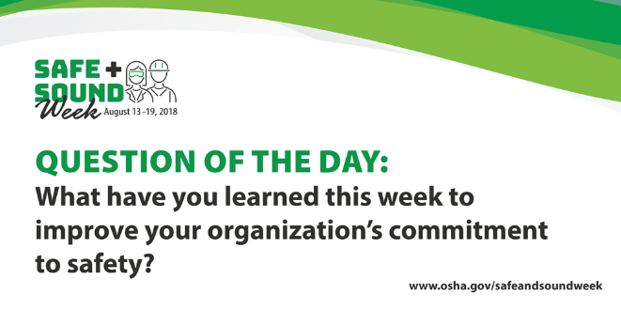

Additional Resources

Partner Communications Toolkit

Press Release

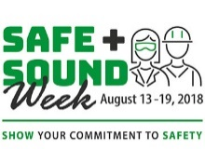
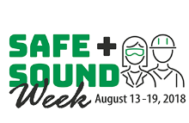
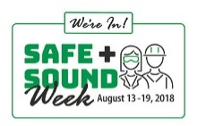
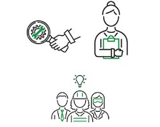
Logos

Animated logos (zip download for posting on Twitter)
Animated logo and web badge (gif URLs for posting on Facebook)

Decal
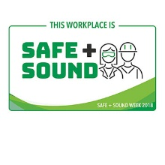
Frames

Motion Graphic

